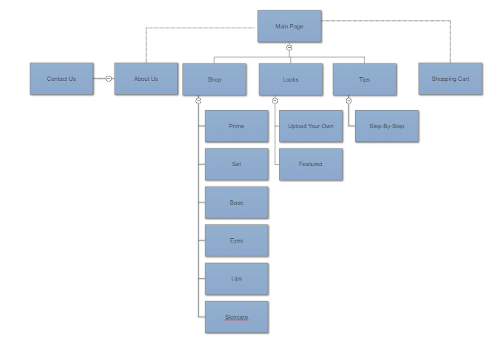

Once at the main page of our website “Parlaur Beauty”, you can click on a few different tabs. The first on is the ‘shopping’ tab where you can view all the products organized by the type of product they are. The next tab is the ‘Looks’ tab where you can upload pictures of your own makeup looks as well as view other people’s looks. The last tab is the ‘Tips’ where you can view videos to teach you step-by-step how to create the same make-up looks. From any page, you can check your shopping cart. At the bottom of the site, there will be two tabs. ‘Contact Us’ where they will find contact information and ‘About us’ where they can read how we got started.

We will be using HTML, CSS, PHP, mySQL, JavaScript, and JQuery.